Recording Screencasts Using
the Bamboo Tablet
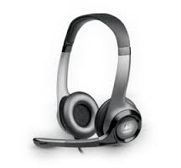
Download Screencast-o-matic free or $12 for unlimited recordings from
http://www.screencast-o-matic.com

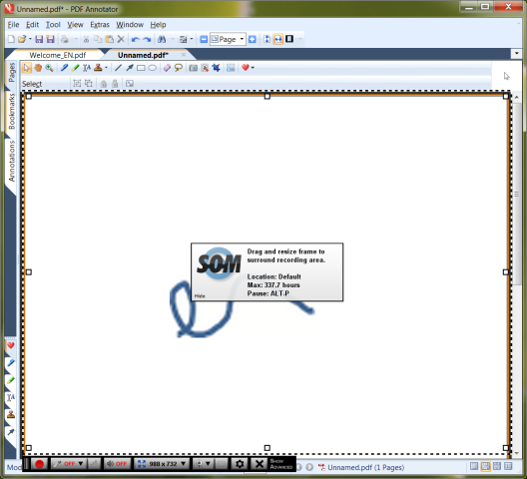
See some examples of screencasts at
www.sdkljfsdjfskldf;lskdf;l

Run Screencast-o-matic to record your working out aloud using voice and pen
Check your microphone levels first. Then press the red button to start recording and the X to stop recording
Save the recording as a Scree-cast-o-matic clip on the Screencast-o-matic website, or on your own PC, or as a YouTube clip.
Either way, you will be given a URL.
You can then paste this URL into Blackboard or email it to students to see your working /explanation
Borrow a headset from EAIT ITS to record your voice

